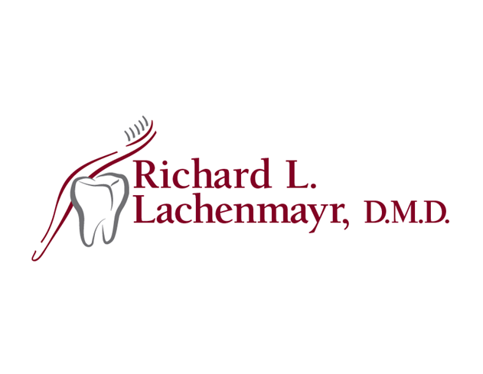

1150 Third Ave., Suite 2, Alpha, NJ 08865
Phone 908.454-8400 ~ fax 908.454.8443
www.drlachenmayr.com

Give Kids a Smile Day
February 1, 2019

FREE dental exams/screenings, prophylaxis (cleaning), oral health education, bitewing X-rays, sealants, and fluoride treatment for children under the age of 18 who are in need and are dentally uninsured or underinsured.

All paperwork and distribution of appointments will take place Saturday, January 26, 2019 from 11-2 in office. If another time is needed, please call the office to schedule. Parent/guardian must accompany all patients.

